**Math 120  
1.8 Inverse Functions**

# Objectives

1. Verify inverse functions.
2. Find the inverse of a function.
3. Use the graph of a one-to-one function to graph its inverse function.
4. Find the inverse of a function and graph both functions on the same axes.

# Topic #1: The Inverse of a Function

In an inverse relationship, the domain and range\_\_\_\_\_\_\_\_\_\_\_\_\_\_\_\_\_\_\_\_\_\_\_\_\_\_\_\_\_\_\_\_

However, inverting a function \_\_\_\_\_\_\_\_\_\_\_\_\_\_\_\_\_\_\_\_ the inverse relation is also a function.

One definition of an inverse is that all members in the domain interchange with their associated member in the range. In other words, each ordered pair $(x,y)$ in the function becomes \_\_\_\_\_\_\_\_\_\_\_\_\_\_\_\_\_\_\_ in the inverse.

Consider the two functions:

Suppose function $f$ consists of the ordered pairs (Why is this a function?):

$$\left(1,0\right), \left(2,1\right), \left(5,2\right), \left(10,3\right), (17,4)$$

The inverse of function $f$ consists of the ordered pairs:

Is the inverse of function *f* a function? Why or why not?

It is worth noting that function f has no repeated x-values ***and*** no repeated y-values. This is the definition of a **\_\_\_\_\_\_\_\_\_\_\_\_\_\_\_\_\_\_\_\_** (abbreviated as 1:1), which tells us the function MUST have an inverse function.

Suppose function $g$ consists of the ordered pairs (this is also a function since no x-values repeat):

$$\left(-1,4\right), \left(0,1\right), \left(1,0\right), \left(2,1\right), (3,4)$$

The inverse of function $g$ consists of the ordered pairs:

Is the inverse of function $g$ a function? Why or why not?

Notice function g has repeated y-values, which results in the inverse relation for function g having repeated x values! (Because the inverse interchanges the x’s and y’s). This tells us that function *g* \_\_\_\_\_\_\_\_\_\_\_\_\_\_\_ have an inverse function.

*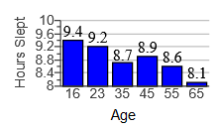Example #1* – Determine if the Function has an Inverse: the graph below shows the average hours slept for select age groups:

Let x be:

Let f(x) be:

a) Write the ordered pairs of the function (this is a function because no x’s repeat).

The ordered pairs are:

$\left(16,9.4\right), \left(23, 9.2\right), \left(35, 8.7\right),$

b) Does the function have an inverse that is also a function? Explain

By definition of inverse, interchange all members of the domain with each member in the range:

Is this inverse relation a function, why or why not?

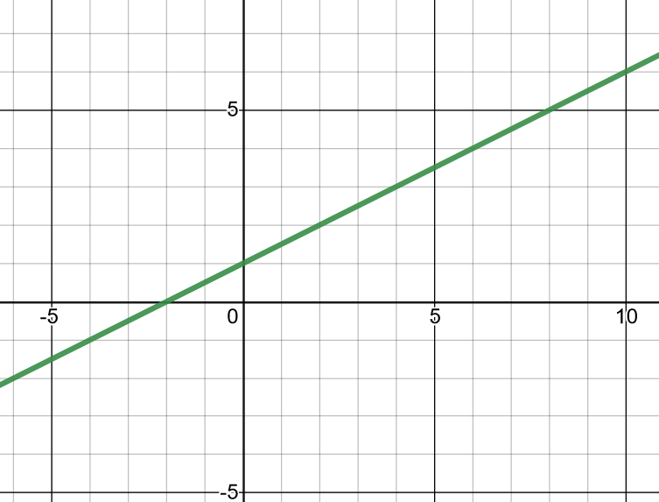*Example #3* – Graph the Inverse for the Function

A graph of $f$ is given, graph its inverse.

If you are given the graph of **ANY** 1:1 function, you can \_\_\_\_\_\_\_\_\_\_\_\_\_\_\_\_\_\_\_\_\_\_\_to sketch the graph of the inverse function.

This is linear, so its inverse must also be a line. All we need are \_\_\_\_\_\_\_\_\_\_\_\_\_\_\_\_\_\_ We can pick any 2 points and interchange them to sketch the graph of the inverse function:

Note the symmetry across the line y=x!

# Topic #2: One-to-One Functions and the Horizontal Line Test

Functions that are \_\_\_\_\_\_\_\_\_\_\_\_\_\_\_\_\_\_(abbreviated as 1:1) have an inverse. Functions that are \_\_\_\_\_\_\_\_\_\_\_\_\_\_ DO NOT have an inverse.

A graph of a function tells us if it is 1:1 or not. If a horizontal line does not intersect the graph more than once, then it is 1:1 since y does not repeat. Consider the graphs of two functions:

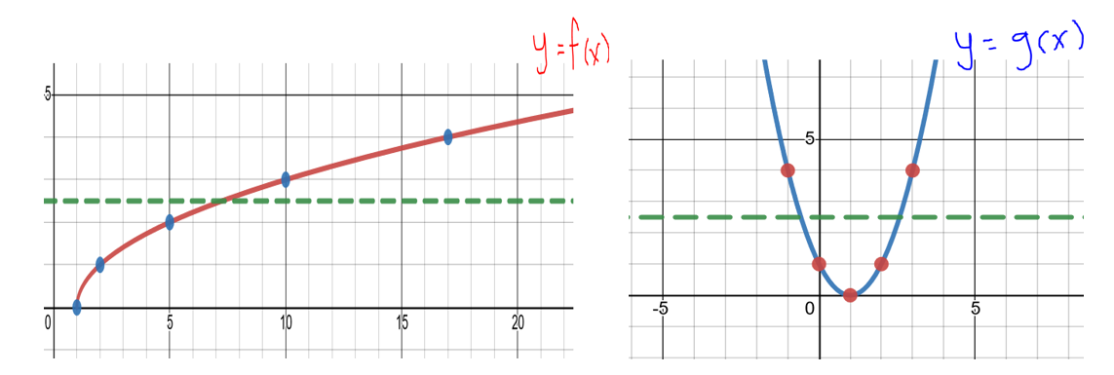

Function $f$ passes the Horizontal Line Test and is 1:1. As a result, function $f$

\_\_\_\_\_\_\_\_\_\_\_\_\_\_\_\_\_\_

Function $g$ fails the Horizontal Line Test and is not 1:1. As a result, function $g$

\_\_\_\_\_\_\_\_\_\_\_\_\_\_\_\_

*YOU TRY #1* – Determine if the Function has an Inverse

The graphs of 4 functions follow.

Which functions have an inverse? Which functions do not have an inverse? Explain your reasoning.

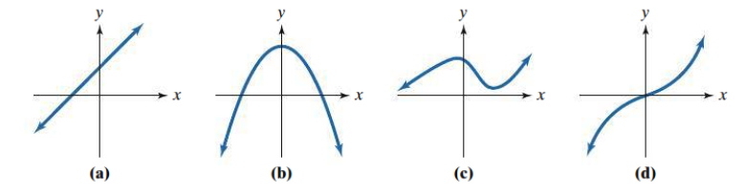

**Formal definition of Inverse function (using function composition):**

Let *f* and *g* be two functions such that

for every x in the domain of g and

for every x in the domain of f.

The function, *g*, is the inverse of the function *f* and is denoted by \_\_\_\_\_\_\_\_\_\_\_\_\_

(read as “f inverse”; the -1 is NOT an exponent!). Thus,  =\_\_\_\_\_ and\_\_\_\_\_\_\_\_\_\_\_\_\_*.*

The domain of *f* is equal to the \_\_\_\_\_\_\_\_\_ of , and vice versa.

*Example #1* - and,

SHOW they are inverse functions using the formal definition above:

*Example #2* - and,

SHOW they are inverse functions using the formal definition above:

*YOU TRY #2* -  and ;

SHOW they are inverse functions:

# Topic #3: Finding the Inverse of a 1:1 Function

When a function is 1:1 it \_\_\_\_\_\_\_\_\_\_\_\_\_\_\_\_\_\_\_\_\_\_\_\_\_\_. If function $f$ is 1:1 and contains the points $(x,y)$, then its inverse $f^{-1}$ contains the points \_\_\_\_\_\_\_\_\_\_\_\_\_

In other words, the inputs trade places with the **\_\_\_\_\_\_\_\_\_\_\_\_\_.**

The domain and the range are interchanged; the domain for $f$ is the \_\_\_\_\_\_\_\_\_\_\_\_\_\_\_ for $f^{-1}$ and the range for $f$ is the \_\_\_\_\_\_\_\_\_\_\_\_\_\_\_\_\_\_\_ for $f^{-1}$

**To find the inverse for a function:**

1. Replace $f\left(x\right)$ with y and \_\_\_\_\_\_\_\_\_\_\_\_\_\_\_\_\_\_ the variables $x$ and $y$;
2. Solve for\_\_\_\_\_\_\_\_ and the result is the inverse for the original function (and the original function is the inverse for the new function);
3. Last, we replace y in the equation for the inverse function with function notation \_\_\_\_\_\_\_\_\_\_\_\_\_

*Example #1* - Consider the function $f\left(x\right)=7x-5$.

To find the inverse function we rewrite without function notation, replacing $f\left(x\right)$ with y:

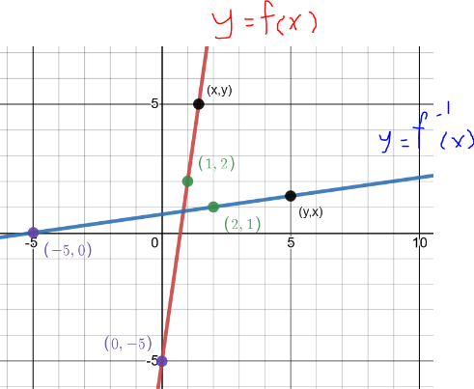Step 1: we interchange $x$ and $y$:

Step 2: we solve for $y$ (this will create a new function where $y$ is a function of $x$).

Step 3: Last, we identify the inverse with the notation.

A graph shows, the 2 functions have all x and y values interchanged.

Another way to look at this and check visually is that the graph of the inverse is the \_\_\_\_\_\_\_\_\_\_\_\_\_\_\_ of the graph of $f$ over the line y=x

Figure is labeled 1.67, The graph of f inverse is a reflection of the graph of f about _______.
(x,y) axis with a blue line, f(x), beginning a third of the way up the y axis from 0, curving upward, labeled graph of f. Green line, f inverse, beginning a third of the way right of the x axis from 0, curving upward and right as a mirror image of the blue line. Dotted line of y=x in the middle, point (a,b) on blue line, point (b,a) on green line.
This is true for every function and its inverse function.

A general graph showing the inverse relationship is shown below

* It is worth pointing out that the operations on the 2 functions in the above example are completely OPPOSITE and IN REVERSE:
* $f\left(x\right)=7x-5$ starts by multiplying by 7, then subtracting 5, and $f^{-1}(x)=\frac{x+5}{7}$ starts by adding 5, then dividing by 7.
* In other words, the original function is \_\_\_\_\_\_\_\_\_\_\_ by the inverse function. Moreover, the inverse function is undone by the original function.

*Example #2* – Find the Inverse for the Function

a) $f\left(x\right)=2x-1$

First, rewrite the function using y in place of *f(x)*:

Next, interchange x and y (which means to apply the definition of inverse):

Solve for $y$ (this is the hardest step):

The last step is to indicate with notation that the above equation is the inverse of $f$:

Notice the operations are OPPOSITES and REVERSED.

The domain for the original function is \_\_\_\_\_\_\_\_\_\_ and the range is\_\_\_\_\_\_\_\_\_\_\_ The inverse function uses the range of the original function for its domain \_\_\_\_\_\_\_\_\_\_and uses the domain for its range \_\_\_\_\_\_\_\_\_\_\_\_

b) $f\left(x\right)=2x^{3}+3$

First, rewrite the function using y in place of *f(x)*:

Next, interchange x and y (apply the definition of inverse):

Solve for $y$:

The last step is to indicate with notation that the above equation is the inverse of $f$:

Notice the operations are OPPOSITES and REVERSED.

The domain for the original function is \_\_\_\_\_\_\_\_\_\_\_ and the range is\_\_\_\_\_\_\_\_\_. The inverse function uses the range of the original function for its domain $____________$ and uses the domain for its range \_\_\_\_\_\_\_\_\_\_\_\_\_\_

c) $f\left(x\right)=\sqrt{x-1}$

Note the domain is \_\_\_\_\_\_\_\_\_ and the range is \_\_\_\_\_\_\_

If you aren’t sure, graph it in your calculator.

First, rewrite the function using y in place of *f(x)*:

Next, interchange x and y (apply the definition of inverse):

Solve for $y$:

The new function has a domain \_\_\_\_\_\_\_\_\_\_\_\_and a range \_\_\_\_\_\_\_\_\_\_\_\_\_\_.

Had the domain of $f\left(x\right)$ not been restricted, then the new function would not be 1:1 and would not be an inverse!

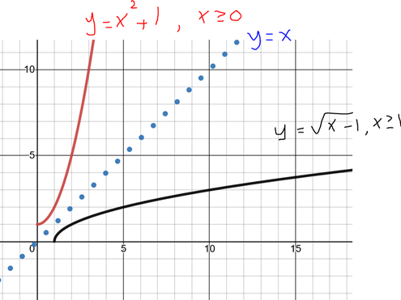

d) $f\left(x\right)=x^{2}+1, \text{for }x≥0$

This function is restricted to make it 1:1.

Note the restricted domain is \_\_\_\_\_\_\_\_\_

and the restricted range is \_\_\_\_\_\_\_

If you aren’t sure, graph it in your calculator.

First, rewrite the function using y in place of *f(x)*:

Next, interchange x and y (apply the definition of inverse):

Solve for $y$:

The new function has a domain \_\_\_\_\_\_\_\_\_\_\_\_and a range \_\_\_\_\_\_\_\_\_\_\_\_\_\_.

A graph of the original functions from example c) and d) show that if function 1 is the inverse of function 2, then function 2 must be the inverse of function 1. Also, notice the symmetry about the line $y=x$.

*YOU TRY #4* – Find the equation for 

Use interval notation to give the domain and range of *f* and *f-1(x).*